Roll No:-96

Name:- Prajwal Santosh Mankar

Practical No:-1

Set up a GitHub account and send an email message to friend telling to your friend about the account.

**Create a GitHub account**

If you don’t already have a GitHub account, here’s how to create one.

1. Open <https://github.com> in a web browser, and then select **sign up.**

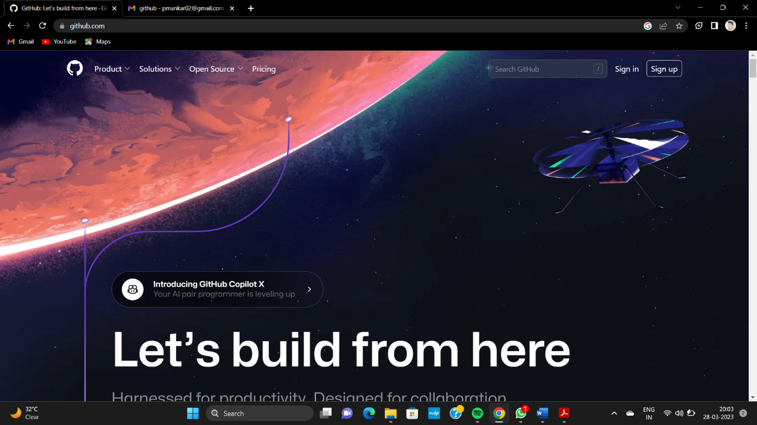

1. Enter your email address.

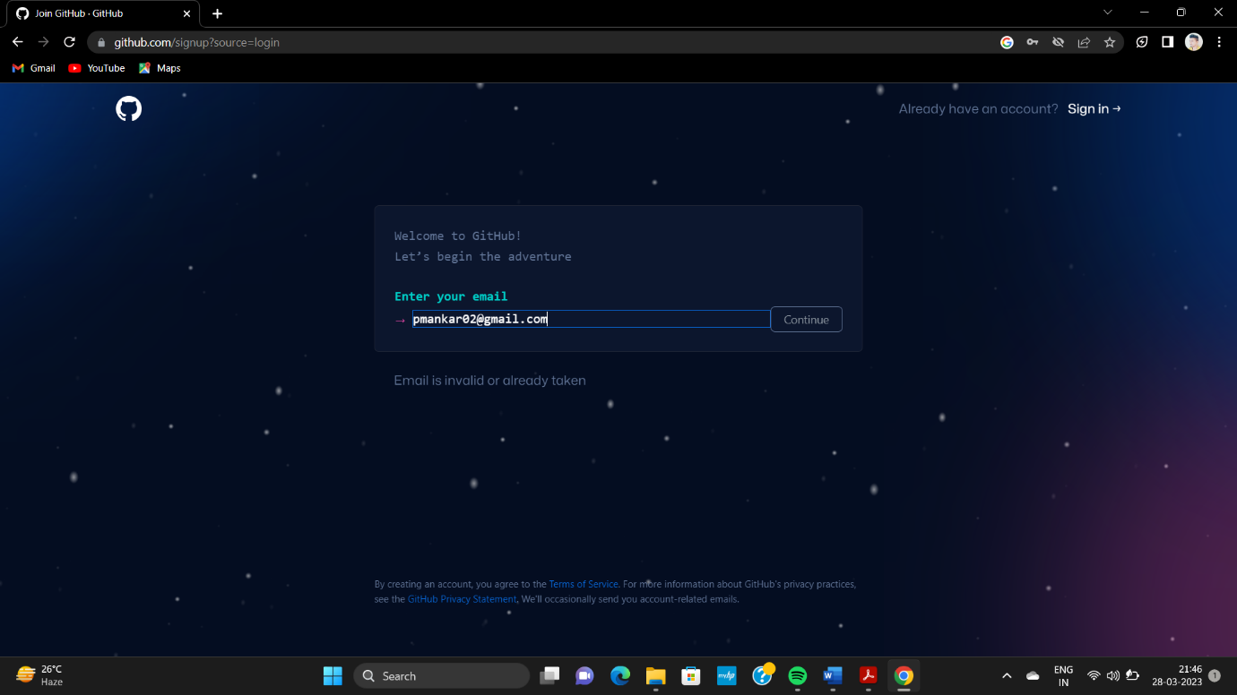

1. Create a password for your new Github account, and Enter a username,

Too.Next,choose whether you want to receive update and announcements

Via emil,and then select continue.

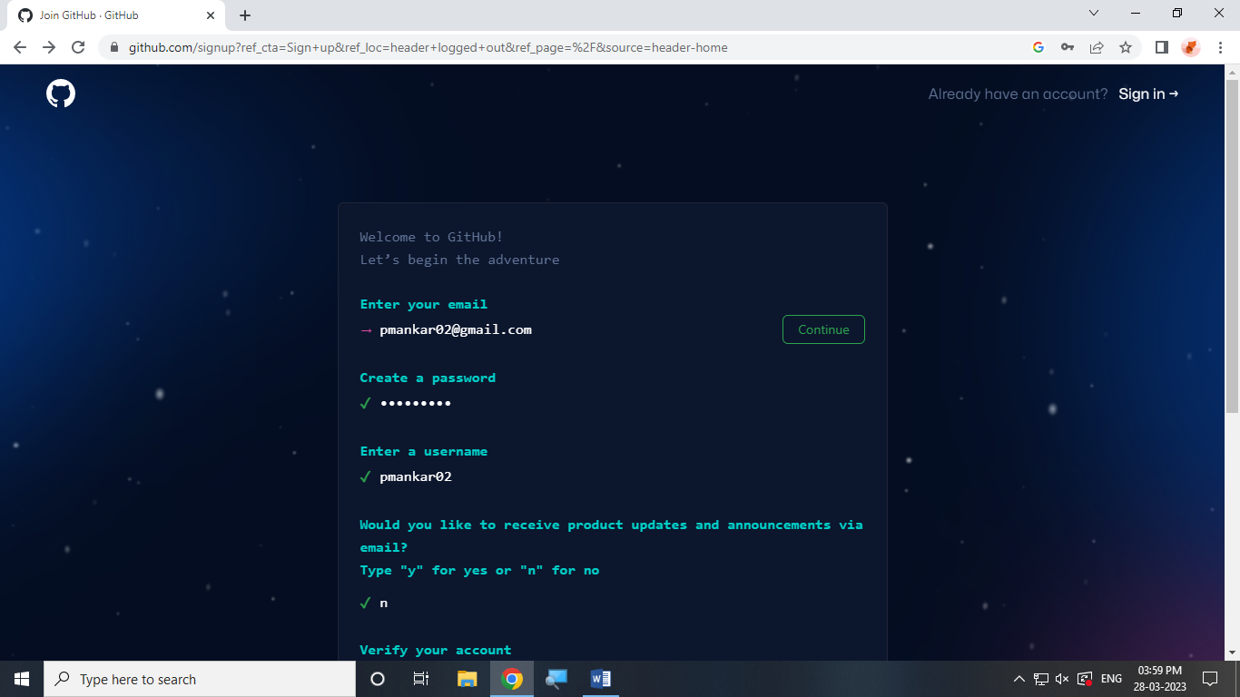

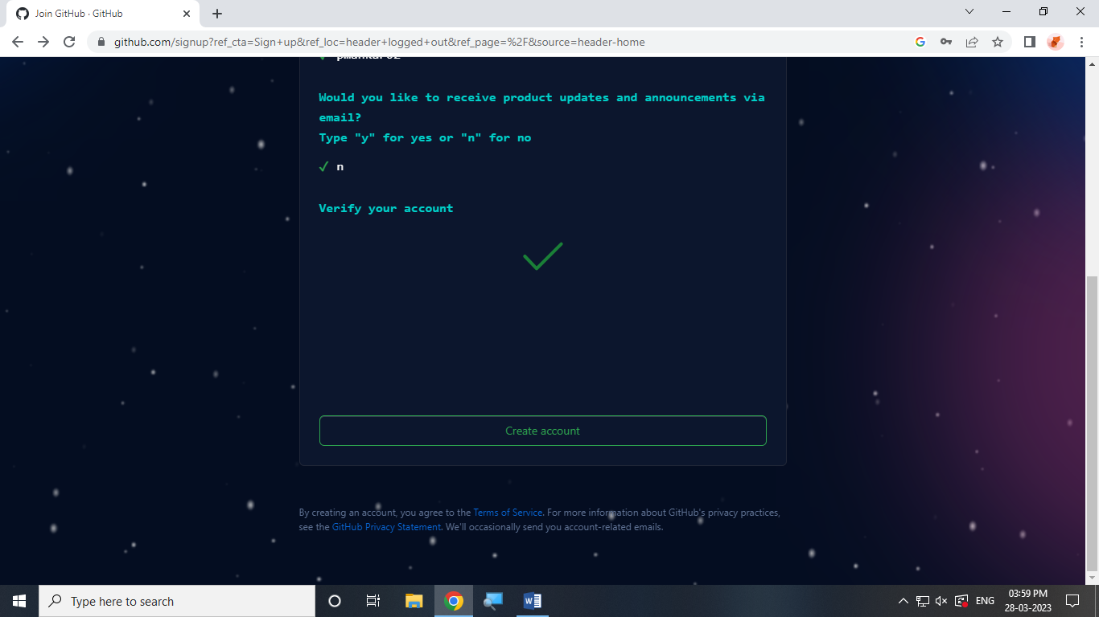

1. verity your account by solving a puzzle. Select the start puzzle button

To do so,and then follow the prompts.

1. After you verify your account,select the Create account button.
2. Next, GitHub sends a launch code to your email address. Type that launch

Code in the enter code dialog,and then press enter.

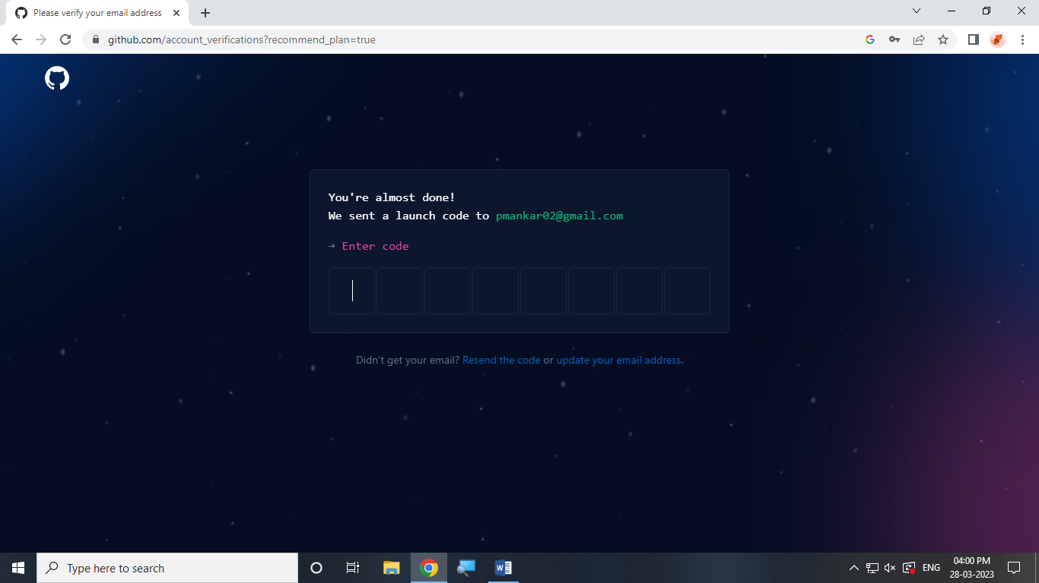

1. GitHub asks you some question to help tailor your experience. Choose the answer that apply to you in the following dialogs:

* How many team member will be working with you?
* What specific features are you interested in using ?

1. On the where teams collaborate and ship screen, you can choose whether you want to use the free account or the team account. To choose the free account,select the skip personalization button.

GitHub opens a personalized page in your browser.

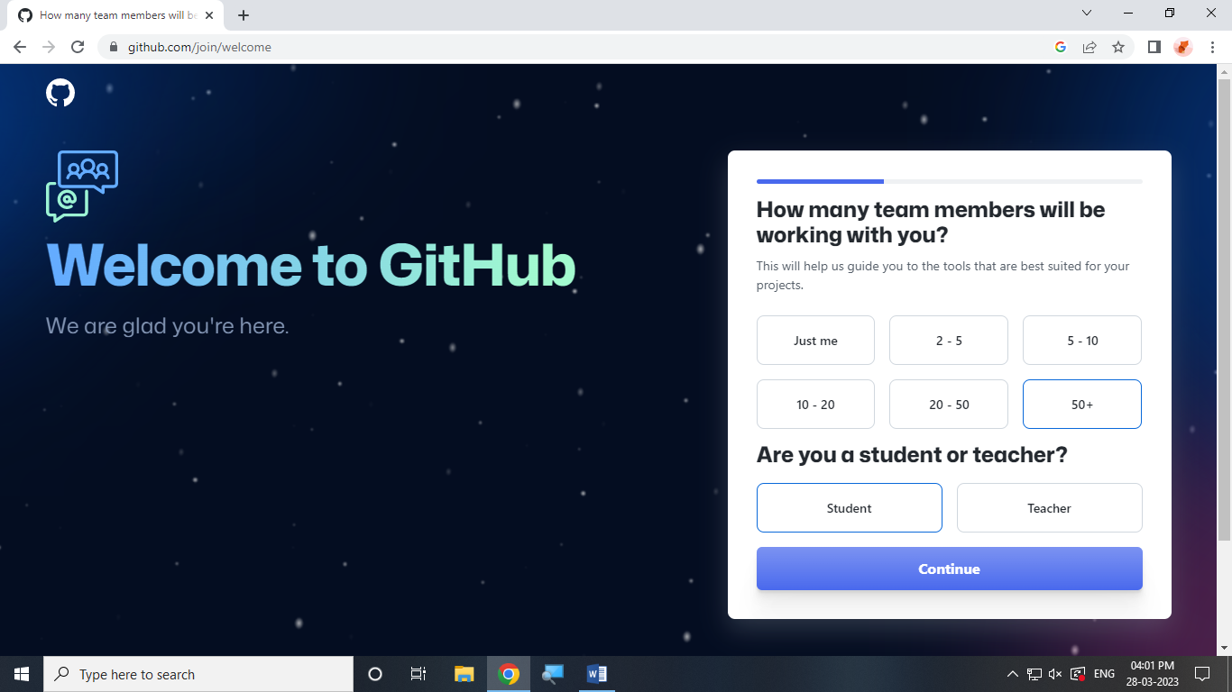

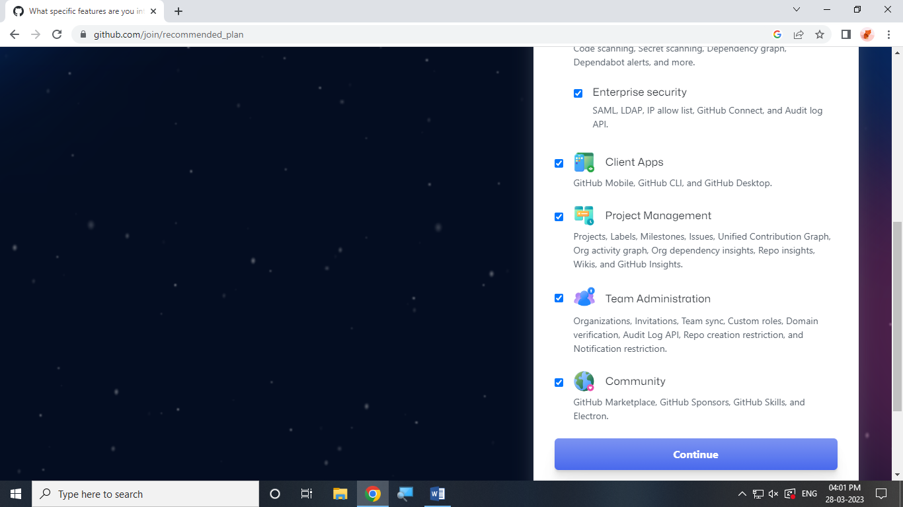

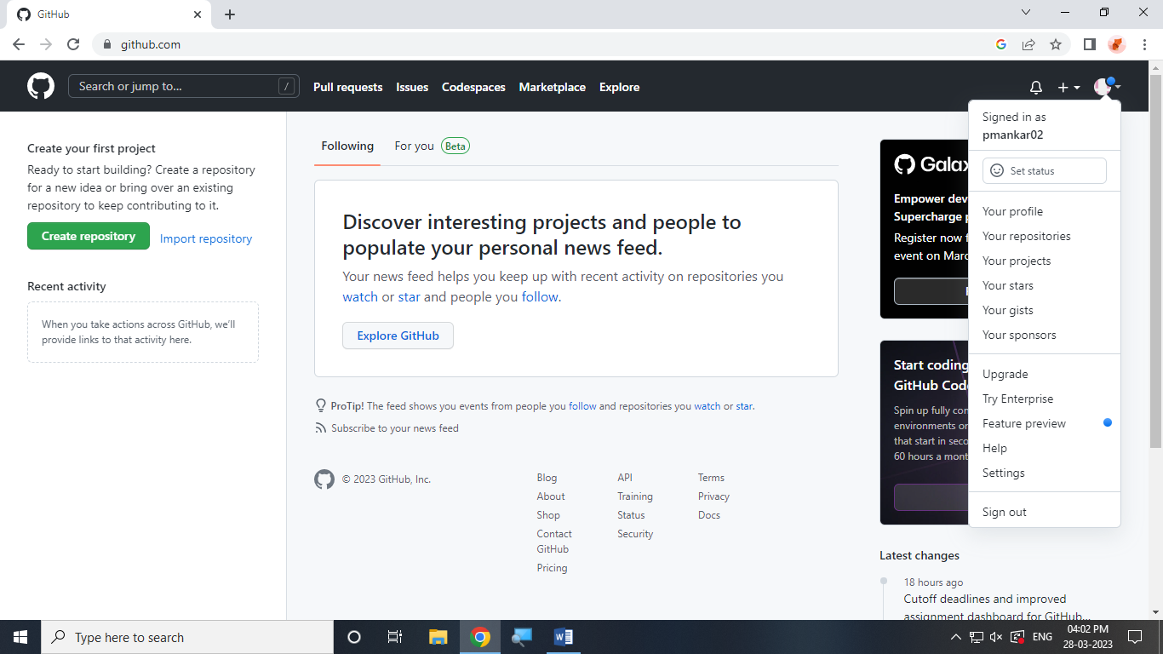

Congratulations! You ‘ve successfully created your GitHub account.

Paste the screen shots of email which you had sent to your friend through GitHub

